Lab: 03

Name: Muhammad Waqas Siddique

Class: BSCS-ev-IV-B

Roll No: 232441

Course: Computer Organization and Assembly Language

Question: 01 Effective address calculation.

* Where is data located in memory for 8086?
* Why is the stack segment used?
* What is meant by saying that 8086 is a 16-bit processor?
* How will it be helpful for a processor if it has large number of registers?

DS= 3333H

BI= 1124H

Physical Address= 3333H\*10H+1124H

Physical Address = 34454H

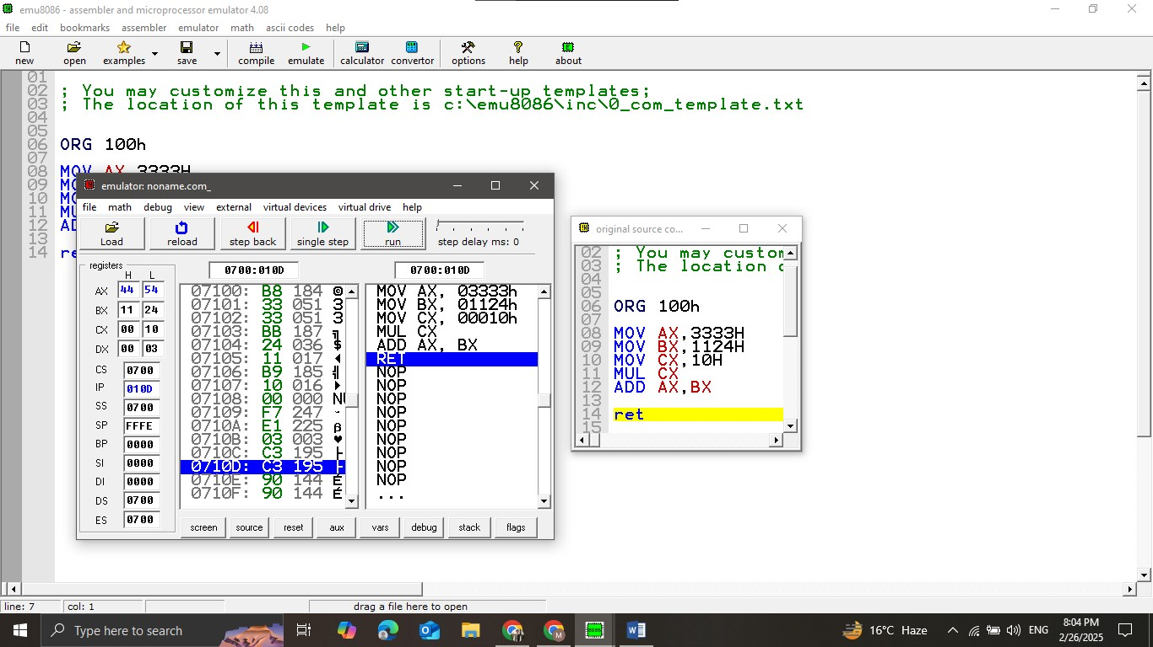

* Data is located in memory segments (CS, DS, SS, ES) addressed via segment:offset pairs.
* The stack segment is used to manage subroutine calls, interrupts, and temporary data storage.
* 8086 is a 16-bit processor because it processes 16 bits of data at a time and has a 16-bit data bus.
* A large number of registers improves performance by reducing memory access and enabling faster data manipulation.

Question: 02

To Understand the Addressing. To explain and identify different addressing modes in 8086.

Show the location of data in memory, after the execution of these instructions, if the

content of registers are as given;

DS= 1112H, AX=EE78H and BX=3400H

i. MOV[0422H],AL

ii. Mov[0424H],AX

iii. MOV[BX], AX

